**Title**: The Use of Explicit Health Benefits Packages Increases Support for Universal Health Care for People with High Objective Numeracy

**Authors**: Sean Duan, BS; Victoria A. Shaffer, PhD

**Purpose**: Universal health care lacks support in the US. Explicit health benefits packages (HBPs) may improve support for UHC by heightening comprehensibility and increasing perceived equality through outlining the cost and scope of care. To test these hypotheses, we compared support for UHC after a HBP intervention, uninformative control, or ‘standard’ UHC messaging from the World Health Organization (WHO).

**Method**: Study 1 (N=189) was a 2(pre-post)x3(condition) mixed-subjects design. Participants were randomly assigned to one of three conditions: 1) building an HBP exercise; 2) reviewing a pre-selected HBP; 3) completing an uninformative control exercise. Study 2 (N=412) was a 2(pre-post)x2(condition) mixed-subjects design with random assignment to either building an HBP or reading WHO pamphlets about UHC. HBP building used the “Choosing Healthplans All Together” (CHAT) simulation exercise where participants constructed their own HBP by allocating a limited set of resources to benefit types (e.g. dental) and choosing scope of coverage (basic-to-high); see Figure 1. Support for UHC was our primary outcome measure; perceived equality (i.e. is UHC seen as fair?) and comprehensibility (i.e. how easy is it to understand UHC?) were included as mediators. All items were measured both pre and post intervention using 0-100 slider-bar scales. In Study 2, we also included the Rasch Numeracy Scale and the Subjective Numeracy Scale as moderators.

**Results**: In Study 1, both HBP interventions increased UHC support versus the control. In Study 2 there was no main effect of the intervention on support for UHC; *ps* < .05. However, there was a significant interaction between the intervention and objective numeracy. Greater objective numeracy predicted increased support for UHC in the intervention versus the control.

Conversely, lower objective numeracy resulted in our control increasing support for UHC more than our intervention. Support for UHC was mediated by perceived equity, but not comprehensibility.

**Conclusions**: Active (i.e., creating your own plan) and passive (i.e., reviewing a pre-selected plan) HBP interventions increased support for UHC but not more than ‘standard’ UHC pamphlets. These interventions appeared to function by highlighting the equity inherent in HBP. However, the interventions were only effective for participants with high objective numeracy. Given that 29% of American adults (approximately 73 million) have low numeracy, it is important to focus future research on alternative approaches that are less quantitatively taxing.

**Word count**: 375 (375 MAX)

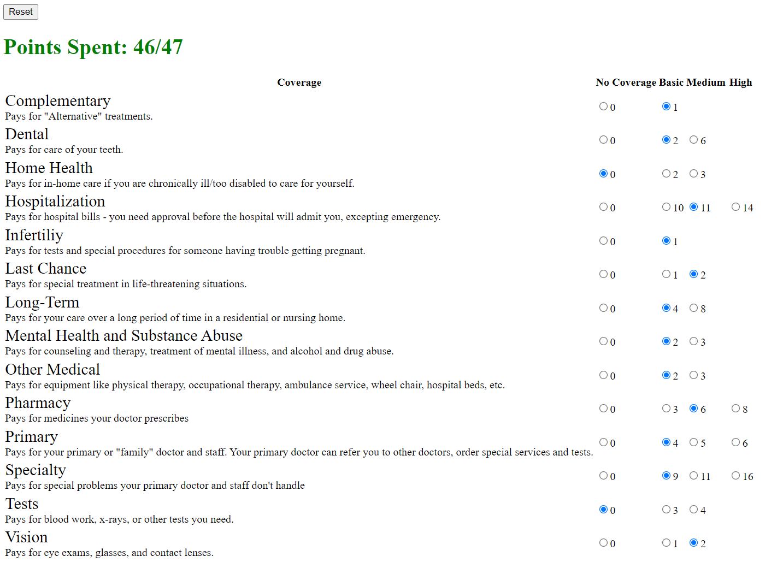Figure 1. Web application of “Choosing Healthplans All Together” exercise. 14 different categories of benefits are available at various levels of intensity. Cost in ‘points’ are chosen using buttons on the right-hand side, with the points limit shown in the upper left-hand corner.